Test 5: numplants = 167 targetsize = (299,299) batchsize = 48 epochs = 100 Model: "sequential" _ Layer (type) Output Shape Param #  
================================================================= inception_resnet*v2 (Model) (None, None, None, 1536) 54336736  
__* global_average*pooling2d (Gl (None, 1536) 0  
__* dense (Dense) (None, 2048) 3147776  
_ dense*1 (Dense) (None, 2048) 4196352  
__* dense*2 (Dense) (None, 1024) 2098176  
__* dense*3 (Dense) (None, 1024) 1049600  
__* dense_4 (Dense) (None, 167) 171175  
================================================================= Total params: 64,999,815 Trainable params: 64,939,271 Non-trainable params: 60,544 72/72 [==============================] - 98s 1s/step - loss: 1.2350 - accuracy: 0.6759 test acc: 0.6759259

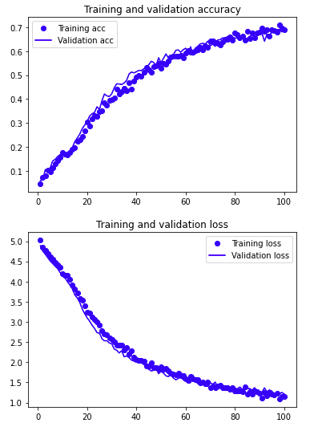

Conclusion: All the inceptionResNet's appear to struggle to break 70% accuracy in the first 100 iterations. Unable to use more advanced EfficientNets as I keep running OOM. I need to learn how to use TPUs on GCP.